**EXHAUSTIVE ANALYSIS OF INDIAN AGRICULTURE USING POWER BI**

**Introduction**

Indian agriculture, the backbone of the economy, employs over 54% of the workforce and contributes 17-18% to the GDP, but faces challenges like weather fluctuations and resource constraints. The "Exhaustive Analysis of Indian Agriculture Using Power BI" transforms data into actionable insights through tools like Power Query, data modeling, and DAX. Power BI’s visualizations, predictive analytics, and AI-driven insights enable analysis of crop yields, market trends, and resource utilization. Real-time collaboration through Power BI empowers stakeholders to enhance agricultural productivity, sustainability, and economic growth.

**STEPS TO DOWNLOAD MICROSOFT POWER BI**

Step 1 -> click on to the Below link and download the application according to system specifications [https://www.microsoft.com/en-us/power-platform/products/power-bi/](https://www.microsoft.com/en-us/power-platform/products/power-bi/%20)

Step 2 -> Download and install the give next-> next-> and finish the process

Step 3 -> Open Microsoft power bi application

**WE CAN START THE NEW PROJECT IN POWER BI**

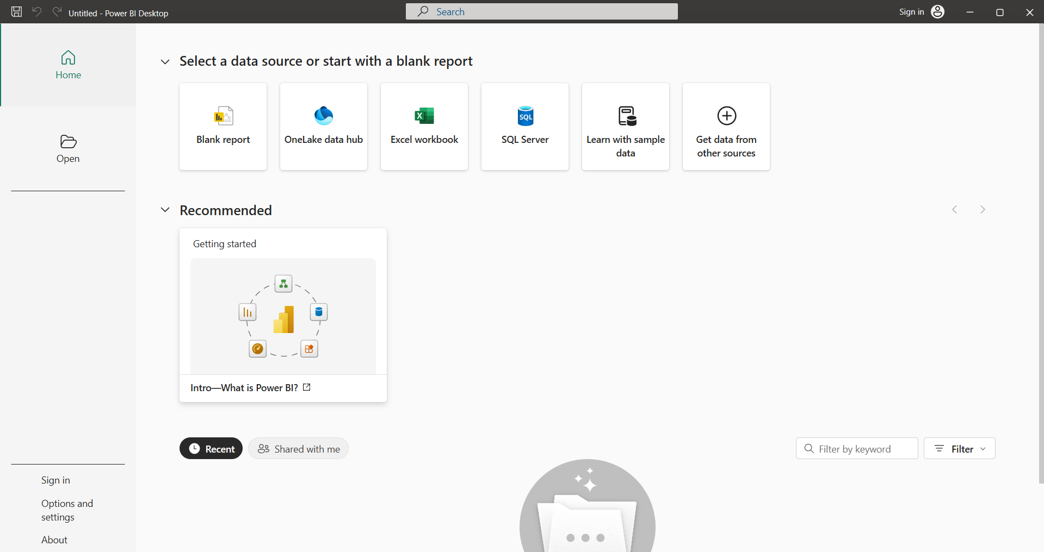

**Step 1:** We can click the black reportfor new project

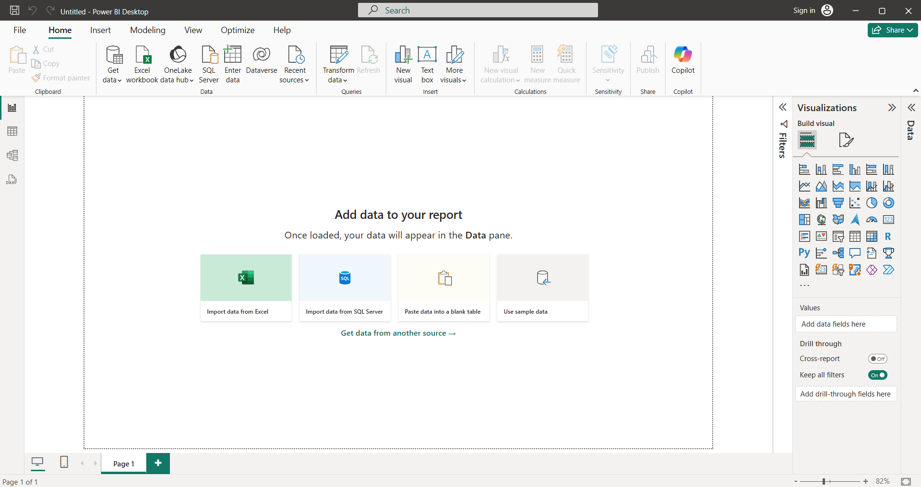

**Step 2:** We can insert the data in the power BI tool and we can click the get data

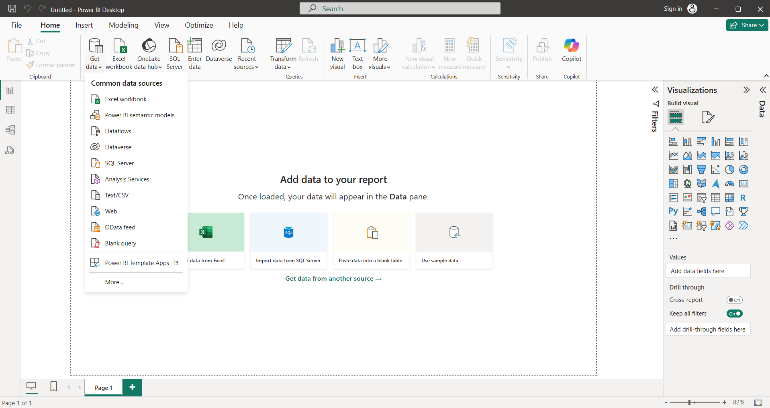

**Step 3:** We can select any one of the related to the dataset file for I have Dataset file is csv file so I can click text/csv row. We can select the file were we can store the file in the system and open the file in the tool.

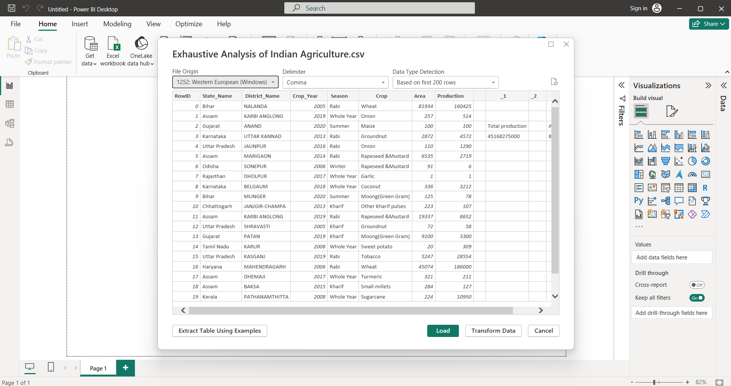

**Step 4:** In this page we can load, transform data and cancel button

Load -> when your dataset is cleaned we can use Load button.

Transform Data-> when you want to process the data we can click the Transform Data.

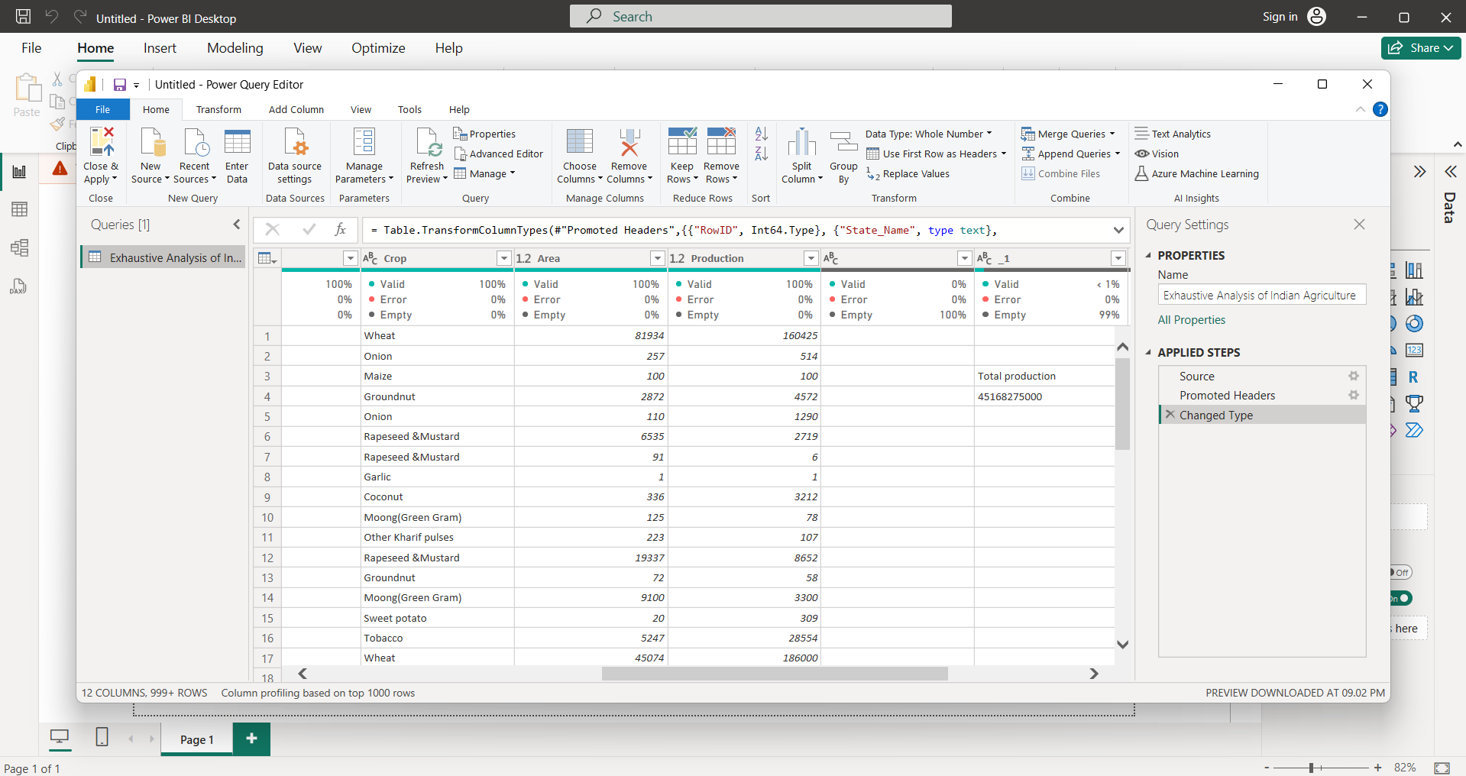

**Step 5:** In this page we can alter the dataset and we can remove the unused column

We can select the unused column and we can click del button in your pc or computer or else we can click the top we can click remove column button in the window.

**Step 6:** We can check the quality of the dataset and we can click view button and click the column quality

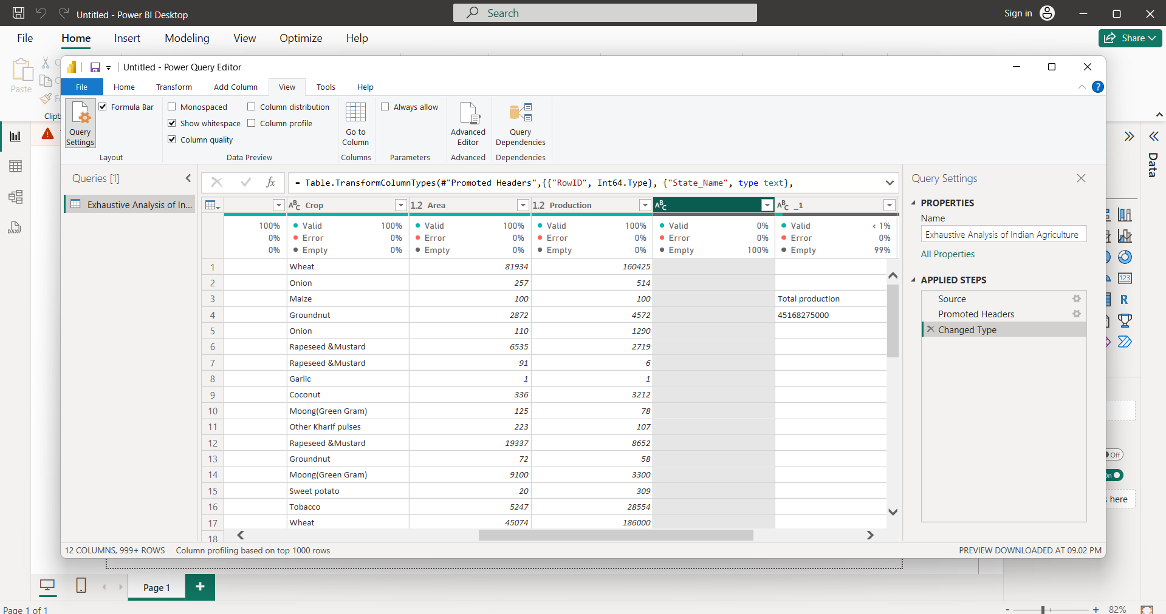

If the error will be there means it can show if no error it will show 0% and No empty column is there It can show 0%.

**Step 7:** We can move home button and click close and apply button

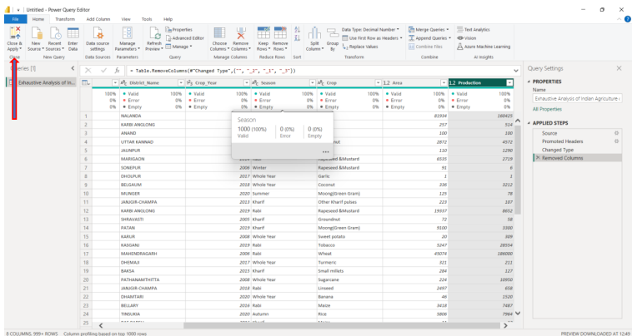

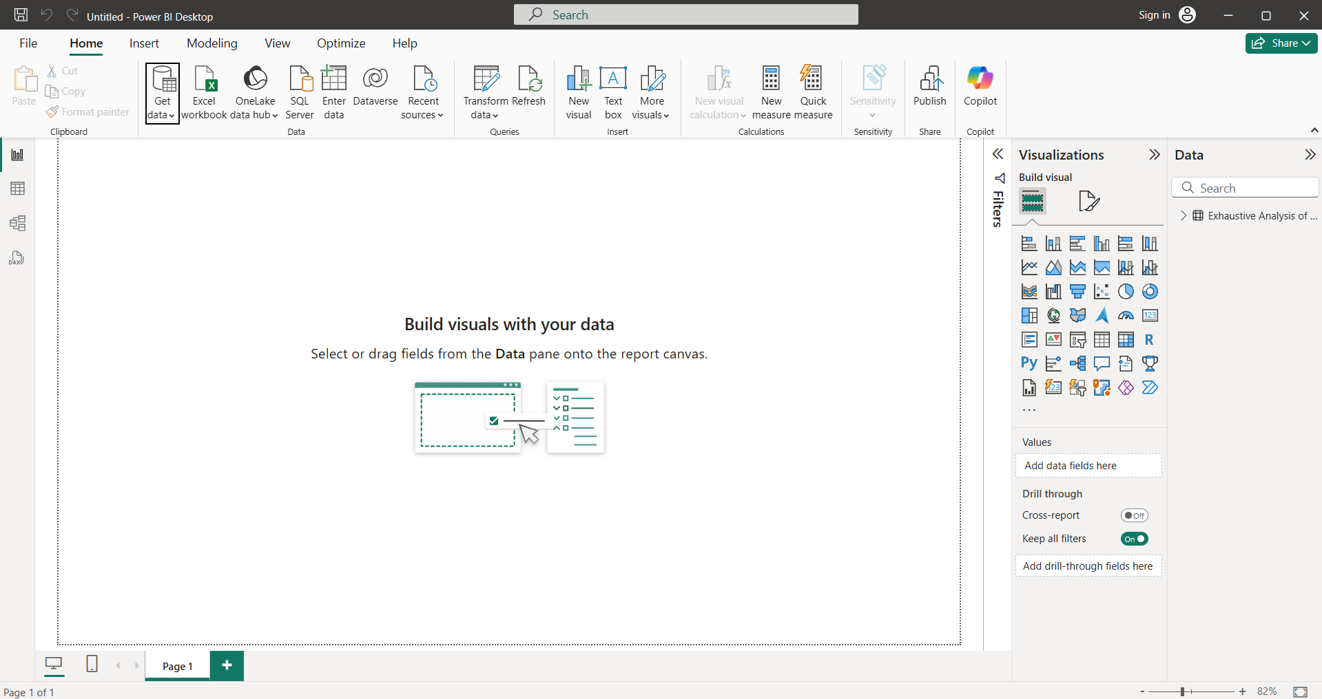

After the complete we can show the image like this.

**Step 8:** In right side will show the table, visuals, model view and dax query view

In left side we can show the table content

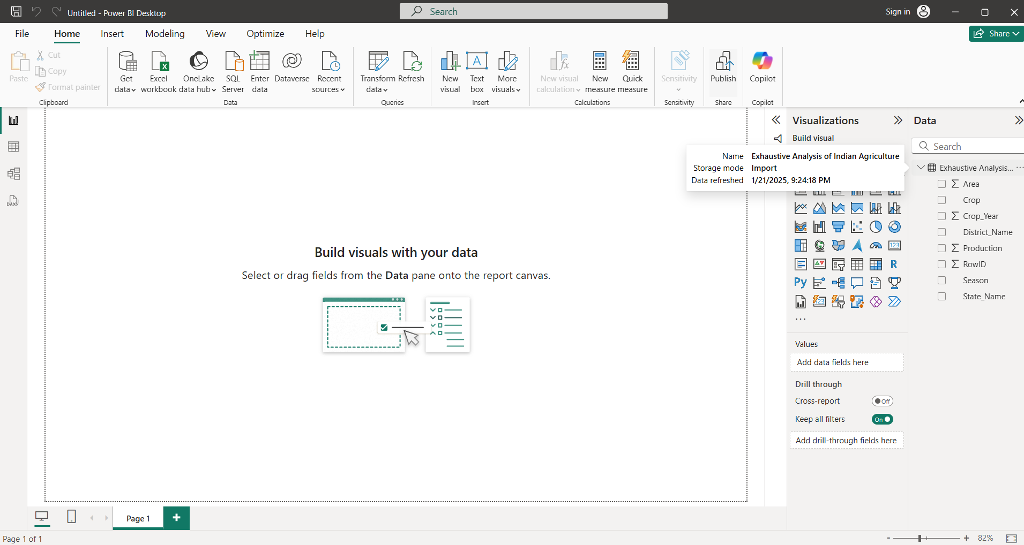

The **visualization button** can be used to create interactive navigation or trigger actions like bookmarking, page navigation, or showing/hiding visuals, enhancing user experience.